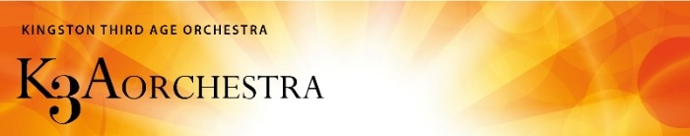
Kingston Third Age Orchestra – a new Commission for 2026

Sponsored by the Humphrey Richardson Taylor Charitable Trust

Background information:
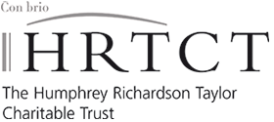
As part of our Young Musicians Programme, the Kingston Third Age Orchestra (K3AO) is very pleased to announce that we are able to invite students or aspiring composers to compose a piece for the orchestra. The first performance will take place at our Winter Concert on 6th December 2026. Thanks to the generosity of the Humphrey Richardson Taylor Charitable Trust (HRTCT), this will be the sixth such commission since the orchestra's inception.

The Orchestra:
The Kingston Third Age Orchestra rehearses on Wednesday mornings during term-time at the Kingston United Reformed Church. The majority of members are retired and have taken up or resumed an instrument following careers in other fields. While maintaining the balance of the orchestra, membership is open to anyone who can attend rehearsals regularly and commit to the concerts. Most of our members are experienced amateurs. This orchestra is conducted and led by professional musicians. More information may be found on the orchestra website http://kingstonthirdageorchestra.org.uk/ .

Requirements:
The proposed composition will need to fulfil certain practical requirements:
(i) Overall length: about 8 minutes, (ii) Form and structure: The form and structure of the piece will be the choice of the composer, (iii) Style: The work must be quasi-tonal, in order to accommodate the preferences and experience of the orchestra, (iv) Limitations: The piece should be purely instrumental, not requiring vocalists or script readers, (v) Scoring: Strings, double woodwind, two horns, 1st trumpet, and timpani. The following additional instruments could be included, if required:-piccolo, cor anglais, 2nd trumpet, extra percussion for one more player, and piano.

The process:
Matching the composer and orchestra for this commission will be crucial for a mutually rewarding outcome. To facilitate this, you are asked to submit an application email that includes:
- an outline of the title, structure and form of the intended composition
- scoring and approximate timing
- an example of a previous instrumental composition, not necessarily for full orchestra i.e. a score and/or a recording
- a short statement, not more than 50 words, of why you would like to work with the orchestra

Timescale and deadlines:
- Applications should be sent to the K3AO by 1st March 2026 via secretary@kingstonthirdageorchestra.org.uk
- The successful applicant will be notified by 24th April 2026. Draft scores and ideas may then be submitted for comment/ feedback until 24th June 2026.
- A full score and parts must be delivered to the Chair, K3AO by 1st September 2026 via secretary@kingstonthirdageorchestra.org.uk .
- Weekly orchestral rehearsals begin on Wednesday 23rd September and it is anticipated that the composer will attend 2 or 3 rehearsals. The composer should expect to meet with the conductor at this stage in order to allow for consultation and any revisions which may be necessary in preparation for the first performance at a concert on Sunday 6th December 2026 at a venue tbc.

Award:
This year the award is £550 on completion of the first performance and, if appropriate, the winner’s music adviser/tutor will receive up to £150 to cover travel expenses in order to attend rehearsals with the orchestra and composer.

27th November 2025

